Since PHP compiler for windows various based on if its XP, Windows 7 or Servers. So the best way to get PHP compiler is to use the toolkit provided by Microsoft itself. Its called web platform installer.

You can download that from: http://www.microsoft.com/web/downloads/platform.aspx
This is just an application MS provided to download other softwares (i.e PHP in our case).

Click the free download button. Then open it and on search box type PHP, which will show your latest PHP complier with your OS compatibility.

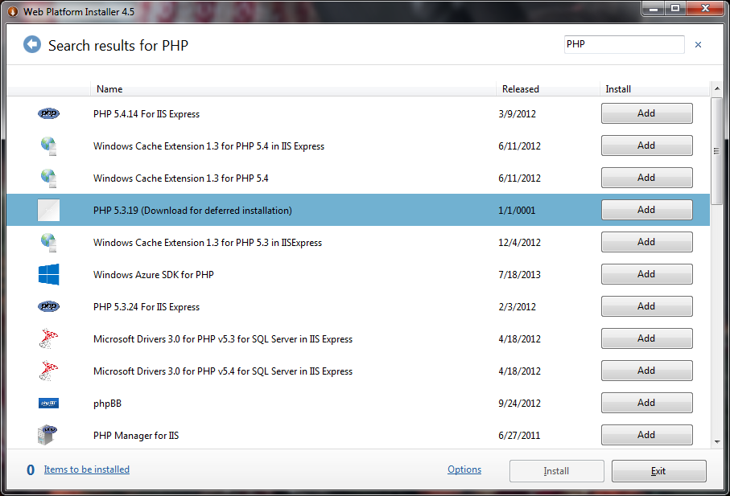

You can either install PHP for IIS or just PHP and take it from there.

After installing, you need to know the path where php.exe is located and provide the same path while using the PHPUbotAddons.dll.

i.e. c:\PHP\php.exe (provided I have installed my PHP complier on c:\php)

NOTE: If you install the PHP 5.3.19 (download for deferred installation) and its not showing in the x86 (64 bit OS) program files folder in 32bit, install the PHP 5.4.14 for IIS Express, and will be located in c:\IIS Express\PHP\5.4.14\php.exe

